PROJECT-37
SOCIAL MEDIA AUTOMATION
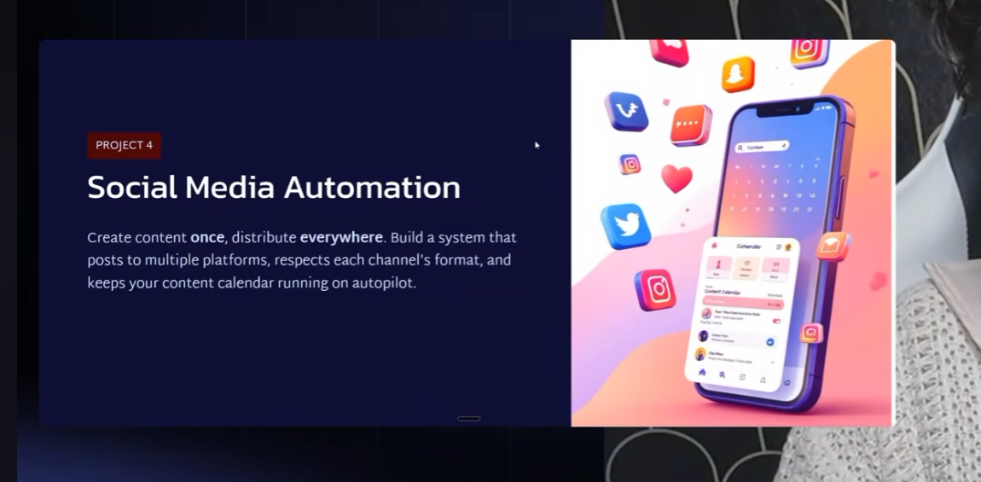
PROMPTS
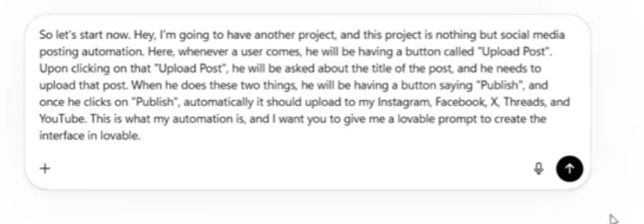
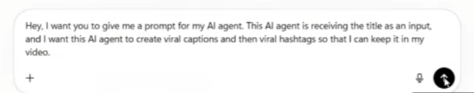
JAVASCRIPT CODE BOCZ OF SAME LINE
Upload post api key

Social Media Video Publishing Workflow — n8n Documentation
1. Project Overview
This workflow is designed to automate social media video publishing.
The workflow receives a request through a Webhook, processes the video and its title, uses an AI Agent to generate social-media content, combines the data, and finally uploads the video through the configured social-media publishing service.
Main workflow
Webhook
│
├──────────────► Upload an asset from file data
│ │
│ ▼
│ Merge
│ │
│ ▼
│ Upload a video
│
└──────────────► AI Agent
│
▼
Code in JavaScript
│
▼
Merge
The AI Agent uses:
Google Gemini Chat Model → AI Agent

2. Objective
The objective of this automation is to:
- Receive a video and post information through a webhook.
- Upload/process the video asset.
- Send the post title to an AI Agent.
- Generate:
  - 1 caption
  - 1 hashtag
- Format the AI output using JavaScript.
- Merge the video information with the AI-generated content.
- Upload/publish the final video.

3. Nodes Used
Node | Purpose
Webhook | Receives the incoming request
Upload an asset from file data | Uploads the incoming video/file
AI Agent | Generates caption and hashtag
Google Gemini Chat Model | Provides the AI model for the Agent
Code in JavaScript | Formats the AI response
Merge | Combines video and AI data
Upload a video | Sends the final video to the publishing service

4. Step 1 — Webhook
Node
Webhook
The Webhook acts as the starting point of the workflow.
It receives the data sent from your frontend/Lovable application.
Method
The screenshot shows:
POST
Therefore, the frontend should send a POST request to the webhook.
Expected input
The request should contain information such as:
Title
Video file
For example:
{
"title": "5 AI tools every student should know"
}
The video should be sent as a binary file.
Role
The Webhook passes the incoming information to two branches:
Webhook
├── Video/File branch
└── AI content branch

5. Step 2 — Upload an Asset from File Data
Node
Upload an asset from file data
This node handles the uploaded video file.
The screenshot shows:
uploadFile: upload
This means the node expects the incoming binary file to be available under the configured binary property.
Purpose
The node uploads the received video and returns information about the uploaded asset.
The output may contain information such as:
Asset ID
Asset URL
File name
File type
Upload status
The exact fields depend on the service being used.
Important
Make sure the Webhook receives the video as binary data and that the binary property configured in this node matches the Webhook's binary property.

6. Step 3 — AI Agent
Node
AI Agent
The AI Agent receives the post title and generates social-media content.
In your workflow, the Agent should generate exactly:
- 1 caption
- 1 hashtag
AI Agent Prompt
Use the following as the Agent's instructions:
You are a Social Media Content Creation AI Agent.

Your task is to create exactly ONE engaging social media caption and exactly ONE relevant hashtag based on the post title provided as input.

INPUT:
You will receive a post title.

TASK:
1. Understand the topic of the title.
2. Create ONE short, catchy, viral-style caption.
3. Create ONE highly relevant hashtag.
4. The caption and hashtag must be directly related to the title.
5. Use simple, natural, and engaging language.
6. Add a hook or curiosity element when appropriate.
7. Do not invent facts that are not provided in the title.
8. Do not create multiple captions or hashtags.

OUTPUT FORMAT:

Caption:
[One caption only]

Hashtag:
[One hashtag only]

IMPORTANT:
- Generate exactly 1 caption.
- Generate exactly 1 hashtag.
- Do not provide explanations.
- Do not provide multiple options.
- Do not include extra text.
- Do not mention that you are an AI.

7. Step 4 — Google Gemini Chat Model
The screenshot shows:
Google Gemini Chat Model
connected to the Chat Model input of the AI Agent.
Purpose
Gemini is the language model that powers the AI Agent.
The flow is:
Post Title
↓
AI Agent
↓
Google Gemini
↓
Caption + Hashtag
Configuration
Configure your Google Gemini credentials in n8n.
Then select the Gemini model available in your n8n setup.
For example:
Google Gemini Chat Model
│
└── connected to AI Agent
Important
The AI Agent cannot properly execute without a configured Chat Model.
The red warning icon shown in the screenshot indicates that one or more required settings/credentials are currently missing.

8. Step 5 — Code in JavaScript
Node
Code in JavaScript
This node receives the AI Agent's response.
Its purpose is to convert the AI response into clean fields that can be used by the next nodes.
For example, the AI might return:
Caption:
These 5 AI tools can change the way you study! 🤖

Hashtag:
#AITools
The Code node can convert this into:
{
"caption": "These 5 AI tools can change the way you study! 🤖",
"hashtag": "#AITools"
}
Recommended JavaScript
If your AI Agent returns its response in output, you can use:
const text = $json.output || "";

const captionMatch = text.match(/Caption:\s*([\s\S]*?)(?=\nHashtag:|$)/i);
const hashtagMatch = text.match(/Hashtag:\s*(#[A-Za-z0-9_]+)/i);

return [
{
json: {
caption: captionMatch ? captionMatch[1].trim() : "",
hashtag: hashtagMatch ? hashtagMatch[1].trim() : ""
}
}
];
Output
The Code node produces:
{
"caption": "These 5 AI tools can change the way you study! 🤖",
"hashtag": "#AITools"
}

9. Step 6 — Merge
Node
Merge
The Merge node combines information coming from two different branches.
In your screenshot, the Merge is configured as:
append
Input 1
The first input comes from:
Upload an asset from file data
This contains the uploaded video/asset information.
Input 2
The second input comes from:
Code in JavaScript
This contains:
Caption
Hashtag
Purpose
The Merge node brings the two branches together.
Conceptually:
Video information
+
Caption
+
Hashtag
↓
Combined data

10. Step 7 — Upload a Video
Node
Upload a video
The final node is responsible for uploading/publishing the video.
The screenshot shows:
uploadVideo
This node receives the information from the Merge node.
Expected information
The final node should have access to:
Video / Asset
Caption
Hashtag
Depending on the publishing service, these fields may be mapped to:
Video URL / Asset ID
Caption
Description
Hashtags

11. Complete Data Flow
The entire automation works like this:
Step 1
User submits:
Title:
5 AI tools every student should know

Video:
student-ai-tools.mp4
Step 2
Webhook receives the request.
Webhook
Step 3
Video goes to the asset-upload branch.
Webhook
↓
Upload an asset from file data
Step 4
Title goes to the AI Agent.
Webhook
↓
AI Agent
↓
Gemini
Step 5
Gemini generates:
Caption:
These 5 AI tools can completely change the way you study! 🤖📚

Hashtag:
#AITools
Step 6
JavaScript separates the content:
{
"caption": "These 5 AI tools can completely change the way you study! 🤖📚",
"hashtag": "#AITools"
}
Step 7
Merge combines:
Video Asset
+
Caption
+
Hashtag
Step 8
The final node uploads/publishes the video.
Upload a video

12. Recommended Workflow Structure
Your final n8n workflow should look like this:
┌──────────────────────────────┐
│ Upload Asset From File Data │
└──────────────┬───────────────┘
│
│
┌──────────┐ ▼
│ Webhook │ ─────────────────► MERGE ─────────► Upload a Video
└────┬─────┘ ▲
│ │
│ │
▼ │
┌──────────┐ ┌────┴─────┐
│ AI Agent │ ───────────────► │ Code │
└────┬─────┘ └──────────┘
▲
│
┌────┴──────────────┐
│ Gemini Chat Model │
└───────────────────┘

13. Testing Procedure
Test the workflow in this order.
Test 1 — Webhook
Execute the workflow and send:
Title: 5 AI tools every student should know
Video: test video
Confirm that the Webhook receives both the title and video.
Test 2 — Asset Upload
Check whether:
Upload an asset from file data
successfully receives the video.
Test 3 — AI Agent
Check whether the Agent produces:
Caption: ...
Hashtag: #...
Test 4 — JavaScript
Confirm the output contains:
caption
hashtag
Test 5 — Merge
Confirm that the Merge output contains both:
Video/Asset information
+
AI-generated caption and hashtag
Test 6 — Final Upload
Finally execute:
Upload a video
and verify that the video is successfully uploaded/published.

14. Red Warning Icons
Your screenshot currently shows red warning icons on some nodes.
These generally mean the node needs additional configuration, such as:
- Missing credentials
- Required field not configured
- Missing input mapping
- Invalid parameter
- Missing connection
- Required property not selected
Before testing the complete workflow, open each node with a red warning icon and complete its required configuration.

15. Final Expected Result
The final automation should allow you to send:
Post Title
+
Video
and automatically produce:
Video
+
1 Caption
+
1 Hashtag
and pass everything to the final video-upload/publishing node.
Final workflow
Webhook → Upload Asset + AI Agent → Gemini → JavaScript → Merge → Upload Video
This is a good structure for your AI-powered social media posting automation because the video processing and AI content generation happen in parallel and are combined only before the final publishing step.

